

Smart Heater

## Team Members:

* Gayatri
* Adithya Kannan
* Jeet Shah
* Vaishnavi Bhat

# Abstract

The purpose of this project is to modify the existing water heater by making a device that will maintain the temperature of water within the specified range of temperature by turning off or switching on the device whenever necessary, this is to reduce the problems of overheating of water and also many other problems like wastage of electricity and water. The estimated cost of the project is around 1000 INR.

Components List:

1. LM35
2. LM324
3. Heat Shrink
4. CD4011
5. 12V-230V 1A relay
6. AC-DC Converter
7. Copper Wires

# Phase 1

The outline of the project

Initially, the approach of the problem was planned. A flowchart and the schematics regarding the same were to be made. Also, the parts of the device were mentioned. The components which are being used in the device like operational amplifier as a comparator, window comparators, SR latches, the relay were explained to us with its purpose of use.

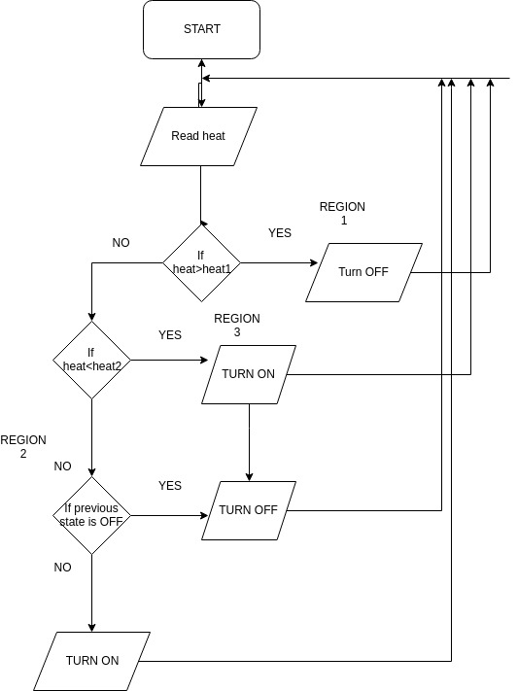FLOWCHART:

Basically, we sense the temperature using LM35 sensor, and get a voltage equivalent of it.

The temperature range of water is divided into 3 regions, one below lower limit (region 3), one above the upper limit (region 1), and one in between (region 2). The input from the temperature sensor is fed into the window comparator arrangement, the outputs from which are given as S and R inputs for a SR latch. So, if the heat is more than that at region 1, the switch will turn off.

If the present state is the region 3, then turn on. If the present state is the region 2, the it depends on the previous state. If the previous state is ON, then it has to retain it. If the previous state is OFF, then we need to keep it OFF.

This took us about 2 weeks to understand the components used and come up with a flowchart.

During this period, we read about the temperature sensors, the SR latches, Window comparator, and the basics of KiCad which we used to make the schematics.

# Phase 2

In the second phase of our project we had the design ready for the window comparator and the SR Latch (using NAND Gates).

After this we proceeded towards making the design for the PCB on the software called KICAD.

We made the schematics for all the parts individually before proceeding towards board designing (As shown in figure 2.1

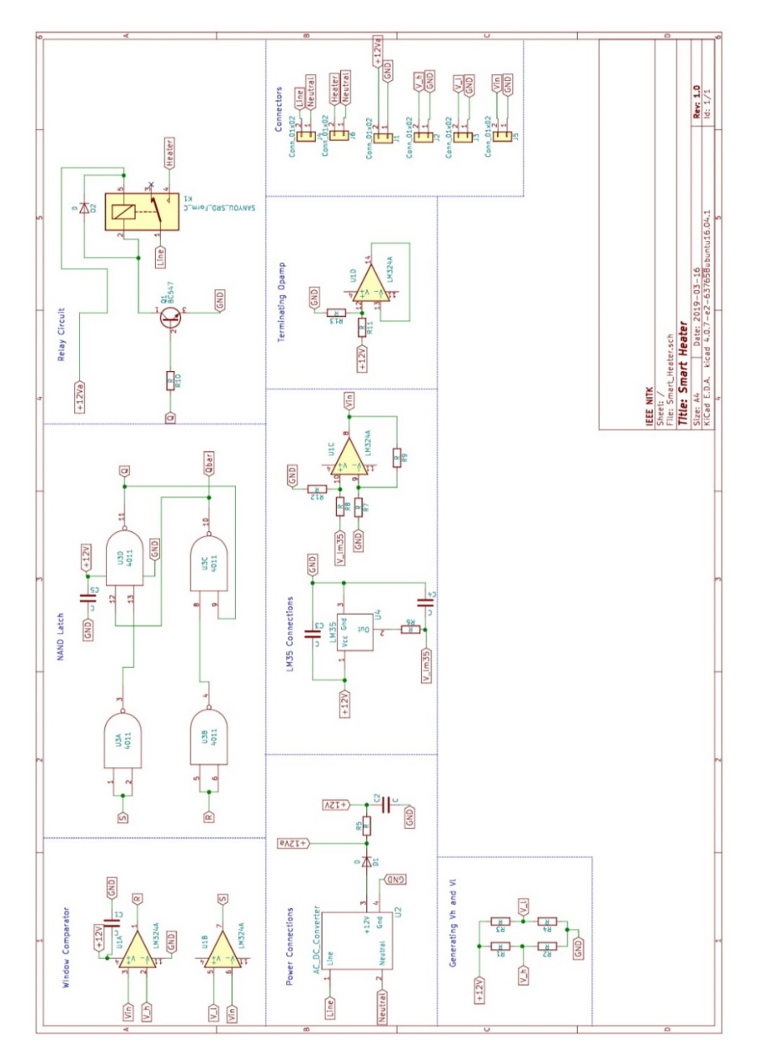

***Fig 2.1***

Then we started making the PCB design on KICAD. there we learnt how to place the components without any overlapping and how to make the project efficient by using less space. All components were placed such that the points to be connected were perfectly placed.

Then we started the routing procedure where all the points to be joined were joined and we made sure the turns were not sharp (i.e. 90 degrees) to prevent accumulation of charge. We tried to form an efficient combination where no 2 lines will cut each other. A template for the AC DC converter didn’t exist in the libraries so we created an AC DC converter component in KICAD and used in our design. And the final output of our design was fig 2.2

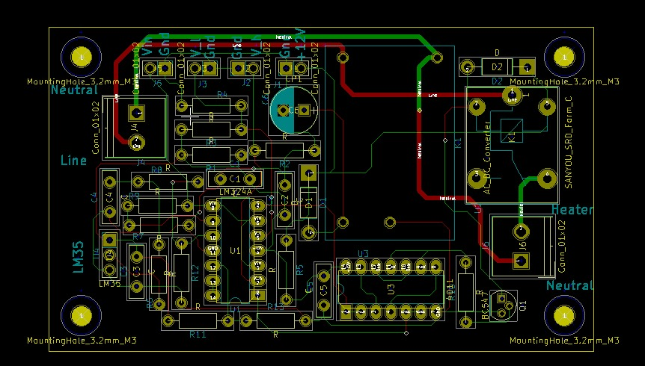

***Fig 2.2***

PHASE 3

The following was done in this phase

-Soldering components onto the PCB

-Waterproofing LM35 using heat shrinks

-Checking connections

-Testing the output (The output is indicated by the turning on or off of a light)

-The silk screen wasn’t printed on the PCB. Hence, the schematic had to be referred over and over again

-The Vcc and ground of the AC-DC convertor were interchanged. The corresponding tracks were cut and appropriate connections were made using copper wires

-This phase started from 17th march and ended at 25th March.

- During the initial testing, false triggering of the relay occurred. To correct this, a base to emitter resistor was added.

